Senate Bill 13-255 Implementation Update:

Colorado Child Fatality Prevention System

What is the Child Fatality Prevention System?
The Child Fatality Prevention Act (Article 20.5 of Title 25, Colorado Revised Statutes) establishes the Child Fatality Prevention System, a statewide, multidisciplinary, multi-agency effort to prevent child deaths. Child fatality review teams at the state and local levels conduct systematic, comprehensive, multidisciplinary reviews of all preventable childhood deaths to better understand how and why children die. Using a public health approach, teams examine the trends of child deaths and make population-based recommendations to improve the health and safety of children.
What did SB 13-255 accomplish?
- Moved the public health review of child deaths from the state level to the local level to align with national best practices for child fatality reviews
- Ensured that all child maltreatment deaths are accounted for and receive a comprehensive review
- Developed a system to create concrete, actionable recommendations to prevent child deaths
Highlights since July 1, 2013
- The Injury, Suicide and Violence Prevention Branch at the Colorado Department of Public Health and Environment (CDPHE) hired three new staff to oversee the new system and provide training and technical assistance to local child fatality review teams.
- CDPHE conducted nine regional trainings throughout Colorado in the fall of 2013, which provided information to 250 participants about the child fatality review process.
- CDPHE provided funding to all local health agencies to support them as they develop local child fatality review teams and contracted with five existing local child fatality review teams to complete the pilot testing of CFPS technical assistance materials and documents and data processes.
- CFPS staff and the State Review Team developed a collaboration website to keep local partners informed as they form local teams (www.childfatalitypreventionco.com).
- CFPS staff developed an operations manual for local review teams.
- CDPHE and its local and state partners developed a comprehensive evaluation plan for the new CFPS.
Next steps
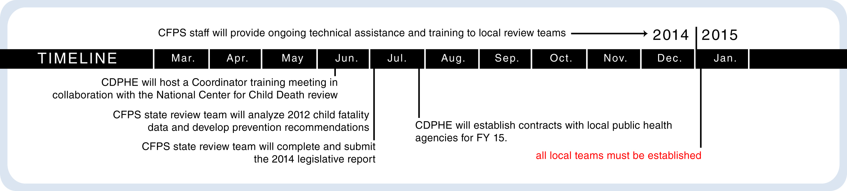

Contacts:
Lindsey Myers, MPH Colleen Kapsimalis, MPH, CPH
CDPHE Injury and Violence Prevention Unit Manager Child Fatality Prevention System Program Manager
lindsey.myers@ state.co.us colleen.kapsimalis@state.co.us
303-692-2589 303-692-2388

