

Keeping Kids Safe and Families Healthy 2.0

*Child Abuse and Neglect Hotline and Public Awareness Campaign*

|  |  |  |  |  |  |
| --- | --- | --- | --- | --- | --- |
|  | FY 2013-14 | FY 2014-15 | FY 2015-16 | FY 2016-17 | FY 2017-18 |
| Total Funds for Awareness & Hotline | $1,013,973 | $9,914,164 | $13,556,314 | $12,170,203 | $11,778,478 |
| General Fund – Public Awareness | $20,198 | $1,812,137 | $1,607,337 | $1,401,337 | $1,009,612 |
| General Fund – Hotline | $988,551 | $7,476,303 | $10,768,866 | $10,768,866 | $10,768,866 |

***Summary of Requests***

* Establish a statewide, toll-free number hotline system that is available 24 hours a day, 365 days a year, and staffed to assist callers reporting concerns of child abuse and neglect that will route calls to the county where the child resides by January 1, 2015, as required by HB13-1271.
* Fund a statewide multi-media public awareness campaign to effectively launch the new statewide child abuse and neglect hotline; and educate mandatory reporters and the general public in all sixty-four (64) counties, as well as two (2) sovereign Indian tribes, on how to identify and report child abuse and neglect.

***Problem/Opportunity***

* A recent statewide survey of 500 adults and two focus groups revealed that up to 49% of the adults surveyed do not know the proper steps to take to report child abuse and neglect. Only 70% of those persons mandated by law to report suspicions could name a proper step to make a report.
* In Colorado, SFY2012-2013 Trails data shows that 15% of the reports of child abuse and neglect are made by family members and only 10% come from the general public. In comparison, New York has higher public engagement in that almost half of their reports come from the general public.
* Each of the 64 counties has its own phone number, staffing requirements for call-takers, and procedures in place to process reports of child abuse and neglect.

***What will change?***

* Community partners, and the State, will be able to leverage marketing tools to educate mandatory reporters and the general public on child abuse and neglect.
* All call-takers will be trained and certified; and supervisors will be able to listen to calls to promote consistency of practice in the state.
* The hotline reporting system will enable all counties, and the State, to collect data related to call volume; dropped calls, average wait times, and average call processing time, as well as record calls to improve quality assurance.

***What won’t change?***

* There will be no “wrong door” to report child abuse to counties or law enforcement. County staff will continue to receive and respond to calls directly.
* Calls will remain anonymous and confidential.

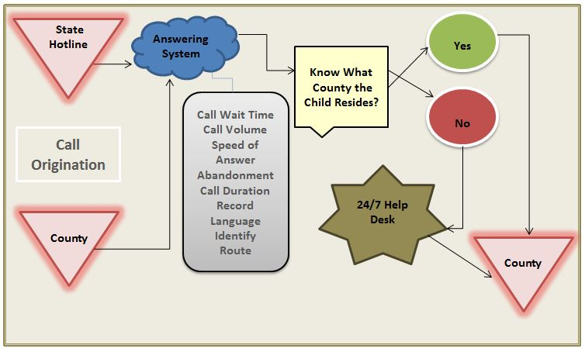***How the Hotline will work?***

***Community Partners in Support***